XPath Union
Pipe operator (|) can be used to specify multiple selectors in XPath. It will match all elements that can be selected by one of the selectors in that list.

Label to form control targeting
HTML label in a form can be used to perform action on corresponding field
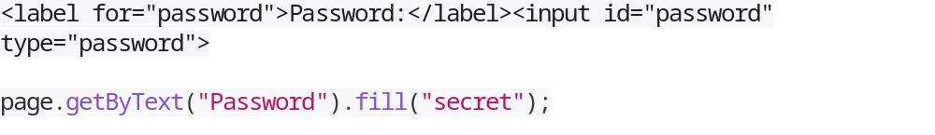
Now using “Password” text of label below actions will be performed by Playwright automatically
- Locator.click() will click the label and automatically focus the input field;
- Locator.fill() will fill the input field;
- Locator.inputValue() will return the value of the input field;
- Locator.selectText() will select text in the input field;
- Locator.setInputFiles() will set files for the input field with type=file;
- Locator.selectOption() will select an option from the select box.

